Practical 10
Aim
To load and display JSON data using fetch() and jQuery $.getJSON(), and to render the results dynamically in a table.
Software Required
- Visual Studio Code (or any code editor)
- Live Server extension for VS Code (to serve the page over http://)
- Web browser with Developer Tools (Google Chrome / Microsoft Edge / Mozilla Firefox)
- jQuery 3.x (loaded from a CDN, so an internet connection is required)
- A JSON data file (data.json) or a public JSON API
Theory
JSON (JavaScript Object Notation) is a lightweight, text-based format for exchanging data. It is built from key–value pairs wrapped in curly braces and ordered lists wrapped in square brackets, and supports strings, numbers, booleans, null, objects and arrays. Because it is language independent and easy for both humans and machines to read, JSON has become the standard format for data returned by web APIs. In JavaScript, JSON.parse() converts a JSON string into an object and JSON.stringify() converts an object back into a string.
AJAX (Asynchronous JavaScript and XML) is the technique of requesting data from a server in the background without reloading the page, so the interface stays responsive while data arrives. Such requests are subject to the browser's same-origin policy and CORS rules; for this reason, a local JSON file cannot be loaded from a page opened directly as file:// and must instead be served over http://, for example with VS Code's Live Server.
The fetch() function is the modern, built-in way to make network requests. It returns a Promise that resolves to a Response object; calling response.json() on it parses the body and returns a second Promise, so the calls are chained with .then() and errors are caught with .catch() (or written with async/await). An important detail is that fetch() only rejects on network failure: an HTTP error such as 404 still resolves, so the code must check response.ok itself. jQuery's $.getJSON() is a shorthand for an Ajax GET request with the data type set to JSON. It parses the response automatically and passes a ready-to-use JavaScript object to the success callback, and it returns a jqXHR object that supports .done(), .fail() and .always(). It requires the jQuery library to be loaded.
Feature | fetch() | $.getJSON()
Origin | Native browser API | jQuery library function
Returns | A Promise (resolves to a Response) | A jqXHR object (Promise-like)
JSON parsing | Manual: response.json() | Automatic: callback receives an object
HTTP errors | Not rejected; check response.ok | Calls .fail() automatically
Dependency | None | Requires jQuery to be loaded

Once the data has arrived as an array of objects, it is rendered dynamically by looping over the array: a table row is created for each record with document.createElement(‘tr’), a cell is created for each value, and the rows are added to the table body with appendChild(). The column headings can be generated from Object.keys() of the first record, so the same code can display any JSON structure. Assigning values through textContent rather than innerHTML keeps the table safe from injected markup.
Implementation Overview
A single-page application named JSON Data Explorer was built. A data source can be chosen — a local data.json file containing twelve student records, or the public JSONPlaceholder users API. The ‘Load with fetch()’ and ‘Load with $.getJSON()’ buttons each request the selected source, and both hand the result to one shared function that builds the table headers and rows dynamically. A status strip shows whether the request is loading, succeeded or failed, together with the method used, the number of records and the time taken. Clicking a column heading sorts the table, a search box filters the rows as the user types, and errors such as a missing file or a failed request are reported with a clear message.
Output
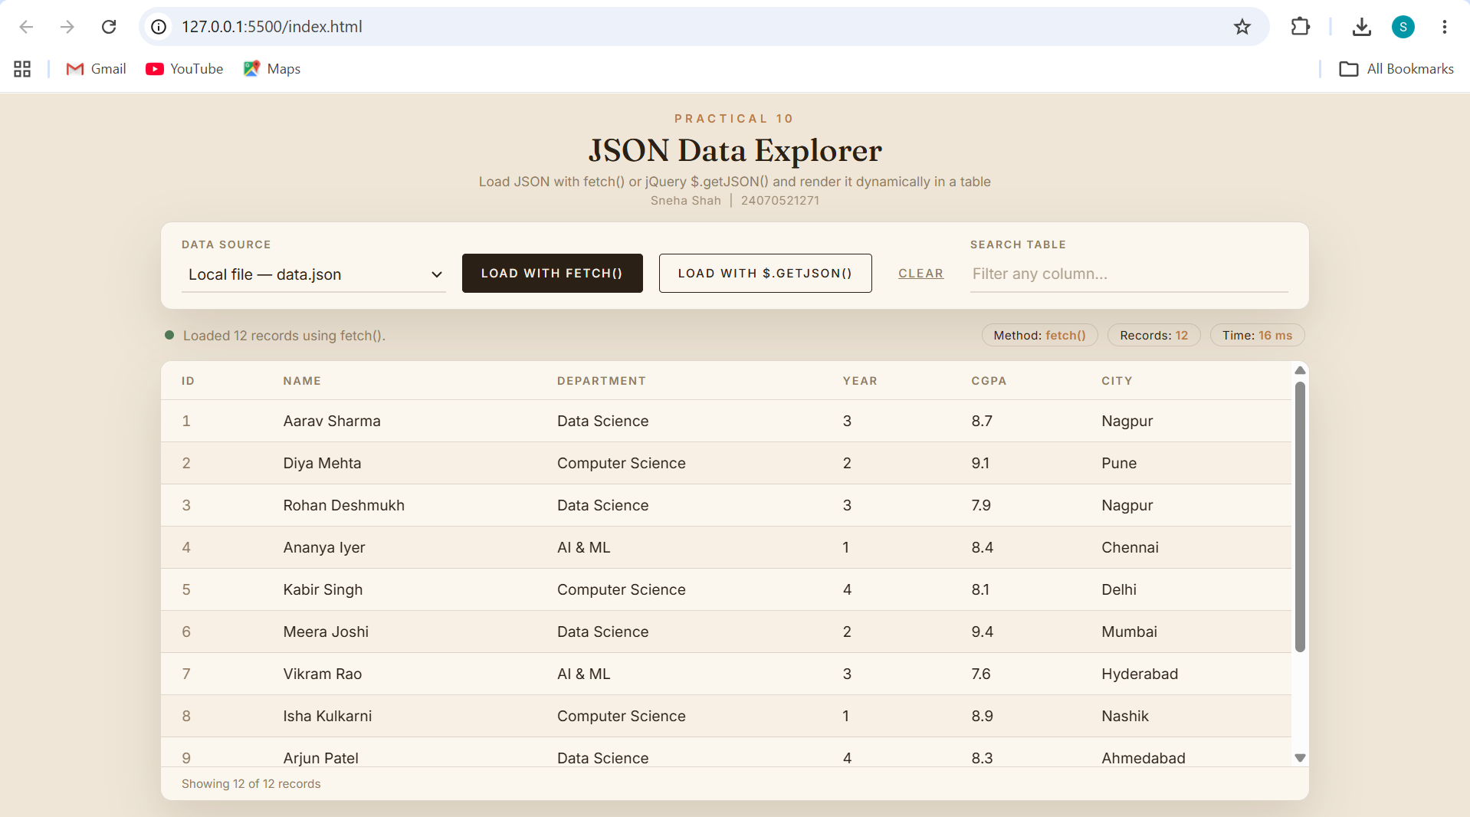
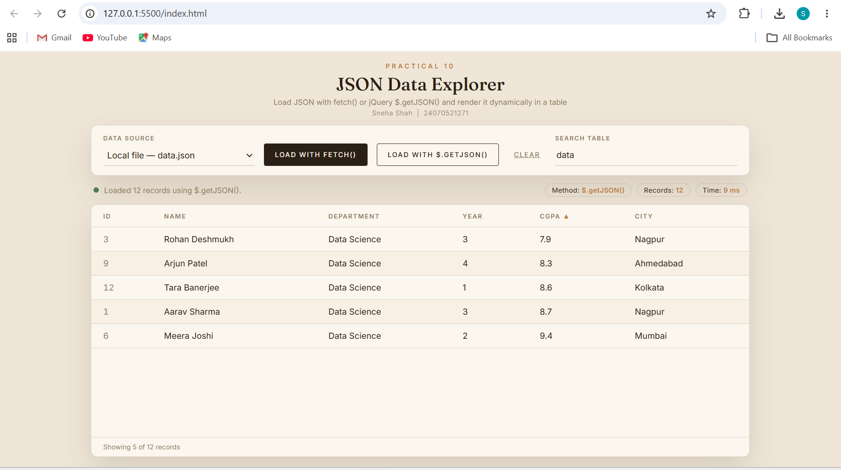
24070521271_SnehaShah
File Path - D:\Symbiosis University\Sem 5\JavaScript\JavaScript VSCode\Practical 10\Case Study\index.html
Result
The application ran successfully through Live Server. Clicking ‘Load with fetch()’ and ‘Load with $.getJSON()’ each retrieved the twelve records from data.json and displayed them in an identical table whose columns were generated from the JSON keys, showing that both methods deliver the same data. The status strip reported the method, record count and load time, the search box and column sorting updated the table instantly without any new request, and a missing file produced an HTTP 404 error message instead of a blank page. The Network tab in the browser's Developer Tools confirmed the JSON request and its response.
Conclusion
Thus, JSON data was successfully loaded using both the native fetch() API and jQuery's $.getJSON() method and rendered dynamically in an HTML table. fetch() is built into the browser and needs no library but requires an explicit response.json() step and a manual HTTP-status check, while $.getJSON() is more concise and parses the response automatically at the cost of depending on jQuery. In both cases, generating table rows from the data with DOM methods allows a page to display fresh data without being reloaded.

